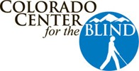
2233 West Shepperd Avenue, Littleton, CO 80120 Phone: (303) 778-1130 Fax: (303) 778-1598
Email: ccb@cocenter.org Website: www.cocenter.org

Annual Report 2024

Our Belief Statement
We believe blind people can do anything. Every day, we encourage and challenge each student and they come to understand their potential as they build the skills and confidence to live the life they want. Because when you believe in yourself and experience a thriving community of positive blind people, nothing can hold you back from pursuing your dreams.
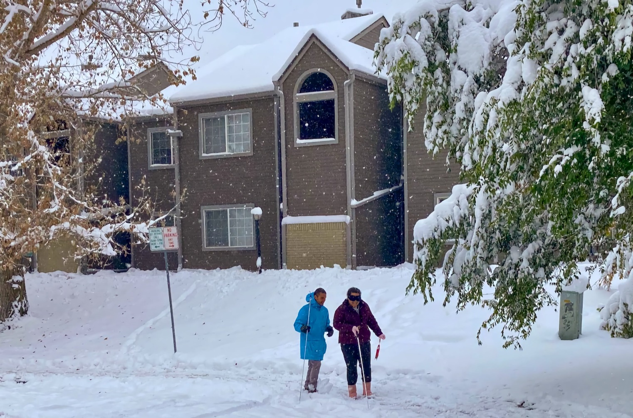
Travel Instructor Ernesto and his student Megan smile as they return from a lesson in the snow.
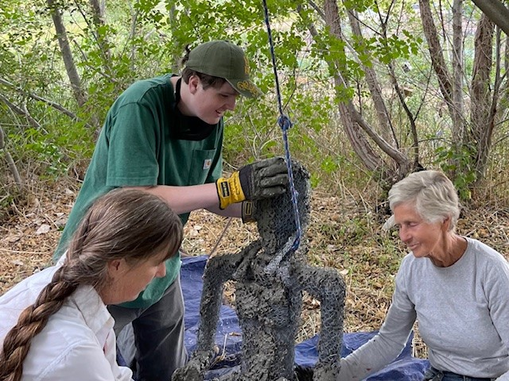
International artist Deborah Manetta donated three concrete yoga sculptures in appreciation for the training her grandson Milo received at the center. They spent nearly a week completing and installing them in our Legacy Garden. Here, Milo’s mom Jen Manetta, Milo and Deborah work on the lotus position sculpture.

At the Colorado Center for the Blind, we know that to live a full and independent life, you need the skills and confidence to manage those challenges that will come your way, as well as the freedom to grow and change as your life’s goals evolve. Our well-rounded training approach helps you build the tools and resilience to solve problems and, thus, the dignity to decide for yourself what you are capable of achieving, now and in the future.

Independence Training Program
The Independence Training Program (ITP) is our cornerstone program, serving working-age adults who want to enter the workforce for the first time or return to work after becoming blind. Students commit to 6 to 9 months of training in the core areas: Braille, Cane Travel, Home Management, and Accessible Technology classes, along with our Philosophy of Blindness class. Students attend these core classes each day to master necessary blindness skills, develop confidence in themselves, and examine the pre-conceived ideas about blindness that can hold them back. We also throw in a healthy mix of weekly courses, such as fitness, martial arts, tactile art, personal development, and home maintenance/woodshop. Challenge recreation activities, like skiing and rock climbing, are designed to further develop students’ confidence in what they can accomplish. The residential component of our ITP program allows each student to practice the skills they are learning in their apartment every day. They travel independently to and from the Center using public transportation. At our apartments, just a little less than two miles from the Center, students become part of a community of other blind people who support and mentor one another. In all of this, our students experience a community of supportive blind people and come to believe in themselves and all that blind people can do.
Fear of blindness and the misunderstanding of what it means to be blind are common, even today. This lack of understanding leads to limited employment opportunities and access for blind and low vision people. We know blind people are capable of doing whatever they decide they want to, so we focus on building the skills, self-confidence, and supportive community they need to thrive on their chosen career paths.
“I was so boxed in,” Ciara recalls of her life before starting the 9-month Independence Training Program (ITP) in March of 2024. “When I first got here, I couldn’t imagine I could ever do these things,” she says of the cane travel graduation requirements, as well as classes in Tech, Braille and Home Management. “Now all my “’can’ts’ have turned into ‘cans.’”
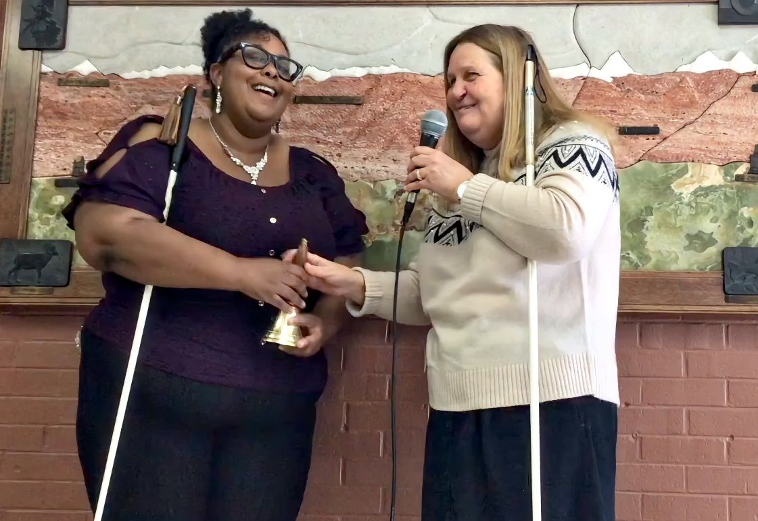
Ciara plans to start at Arapahoe Community College in August 2025 while working as our new front desk receptionist.
We served 65 individuals in ITP over the course of 2024, of which 25 continued their ITP programs into 2025. Ages ranged from 17 to nearly 70, with 11 percent between the ages of 17 and 19. The largest group were between 20 and 29, with 32 percent, followed by 40 to 49 with 20 percent of our ITP students falling in this age range. We also served 4 individuals between the ages of 60 and 69:
- 38 percent of students served in 2024 continued their training into 2025.
- 55 percent successfully completed the program in the calendar year.
- 58 percent of those who completed their programs in 2024 went on to further education or additional job training, such as the Business Enterprise Program.
- 49 percent had additional disabilities along with blindness.
- 54 percent of our students were members of a minority group.

Colorado students comprised 24 percent of our students for 2024, hailing from 7 different counties, Twenty-one states were represented by the 76 percent of students from outside of Colorado. We also had one student from Saudia Arabia in 2024.

Landon started ITP a month after his high school graduation in June 2024. He’s from a small town—the kind of town where everybody knows everybody else.
“Everybody had their idea of what I should do next,” he says. “But I wanted to improve my blindness skills and figure it out on my own. Coming here for training was like taking a gamble on myself.”
That gamble paid off on Landon’s graduation day. As he rang his Freedom Bell, he had the confidence to know he could travel anywhere he wanted to go and that he had just cooked a wonderful meal for 60 fellow students, teachers, family and friends!

Youth Programs
Our youth programming Provides mentorship, training, support and encouragement for blind youth of any age, their parents, educators, or other important persons in their lives.
“I thought that I knew so much about doing things in the kitchen,” said High school student Salma after November’s Conquering the Kitchen Baking Event, “but I learned so many things today that will be helpful at home.”
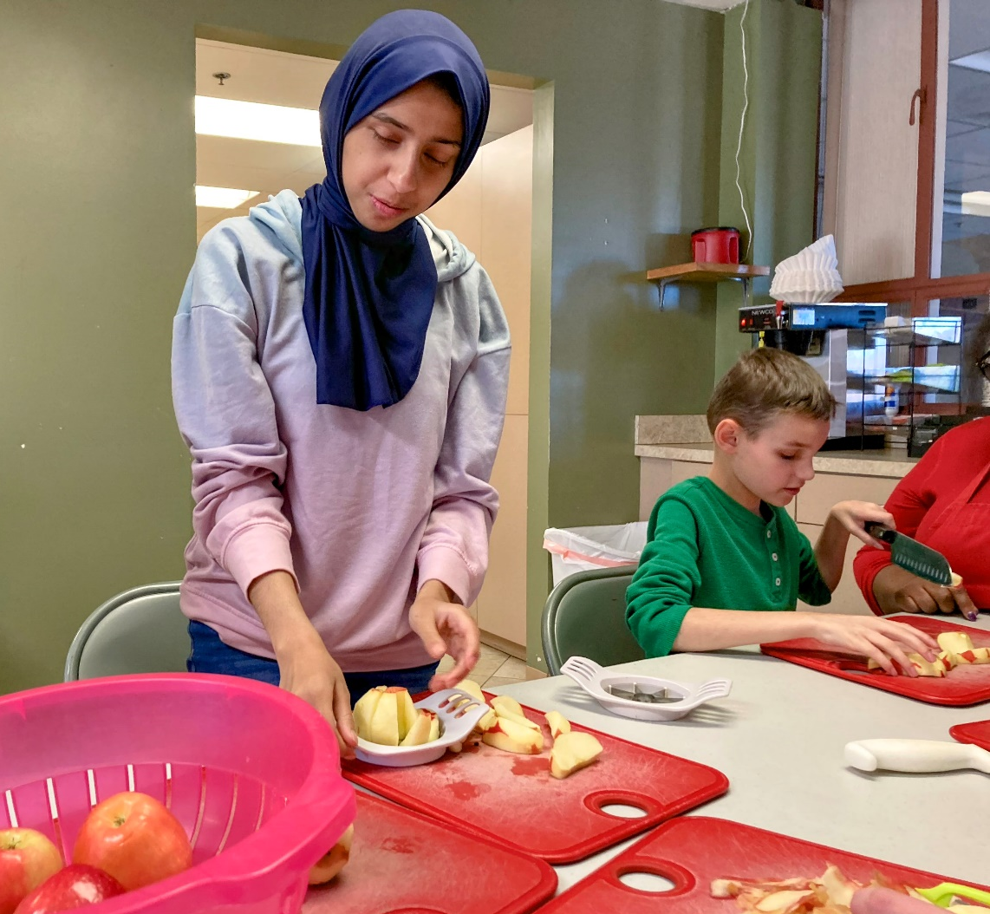
High schooler Salma and middle schooler Cameron sliced a lot of apples that went into the two apple pies they helped bake.

We believe in our blind youth and their futures, so we focus on conveying a positive philosophy of blindness by providing opportunities for learning and challenge they may not find elsewhere. We both lead and actively participate side-by-side with blind youth in these activities. Thus, our blind staff and volunteers model the confidence and competence we seek to instill in our blind youth. Review the list of 2024 youth activities and you will see that we offer an array of opportunities for both learning and challenge ranging from accessible STEM learning to outdoor challenge recreation and much in between.

Highlights
This year’s Youth Program highlights include our first-ever Families with Blind Children Retreat weekend at the YMCA of the Rockies in Estes Park. Six families attended with a total of 14 youth, including sighted siblings. Youth participated in an archaeology hike to pre-Columbian sites on the YMCA grounds, a trip to the archery range, and an evening at the firepit making s’mores. Our staff also provided training to parents and grandparents in the basics of travel with the white cane and safe and effective nonvisual kitchen skills. Parents did both activities under learning shades. And we discussed topics like chores, giving responsibility, high expectations for their blind children at home and in school.
Our summer residential programs in 2024 had 17 participants, ten of which came and lived for four weeks in our apartments with adult mentors and 7 more who came for 7 weeks and attended the National Federation of the Blind convention in Orlando with us. The focus for this latter group was advocacy and collective action, along with the usual core classes and independent living skills.
Combining all youth programs, we served 115 individuals over 26 events. Total participant numbers came to 312 for all events because many students attended multiple activities. Our best-attended event was the trip to Station 12 South Metro Fire and Rescue, with a total of 19 youth in attendance.

List of 2024 Youth Activities
Visit to Station 12 South Metro Fire and Rescue
Music With Feeling: Introduction to musical instruments/emotional learning through music
Youth Skiing Trip at Eldora with Ignite
Metro State of Denver STEM Day for Blind Students
University of Colorado-Boulder’s Build a Better Book Project with Blind Youth and Sighted Teens
University of Colorado-Boulder Fiske Planetarium
Colorado School for the Deaf and the Blind (CSDB) Mentor Visits – 4 trips to Colorado Springs
Families with Blind Kids Retreat at YMCA of the Rockies Estes Park
NFB of Colorado State Convention Sports and Rec Activity
Conquering the Kitchen Baking Event
Multigenerational Holiday Party
Navigating the Great Outdoors: Outdoor Skill Building with Boy Scouts Troop 870
Auraria Pioneers Egg hunt/Beep Baseball
Got Horse Sense? Arapahoe County Sherriff Mounted Unit Horse Meet and Greet
Youth Try-It Accessible Sports Event
Denver Public Schools Baking Event
Astronomy Camp/3D Tactile Exploration with NSF
Summer for Success 7-week Youth Residential Program + NFB National Convention
No Limits to Learning 4-Week Youth Residential Program
Youth Rock Climbing (three trips)
College, Careers and Connections: A Career Fair
Rock climbing for the first time, Timothy, 12, tackled the hardest route of the day—an 85-foot ascent. Back on level ground they beamed and said, “This is my first time climbing, and I made it to the top!” I never knew I’d have so much fun doing something that’s so scary!”

Older Blind Program
Older Americans become blind in greater numbers than any other age group. The fundamental skills and techniques we teach to our older blind folks help them maintain their independence. Since they’ve lived full lives already—careers, relationships, raised families, and more—independence is something they insist on keeping! The Colorado Center for the Blind serves dozens of older blind folks each week with the goal of continued independence.

We offer three weekly and 6 monthly support groups at the Center, on Zoom, or in other locations around the Denver Metro area. We also provide one-on-one training in people’s homes and nearby.

Here is a snapshot of the older blind folks we served in 2024:
- 198 received direct services
- 138 individuals participated in one or more support group
- 48 individuals received services/training during one or more home visits
- 71 individuals received one-on-one training at the Center
- 21 percent were under the age of 70
- 26 percent were between the ages of 70 and 79
- 38 percent were between 80 and 89
- Ages 90 and older comprised 30 percent of those we served in 2024
- 60 percent had additional disabilities
- 76 percent female
- 24 percent male
- 9 percent low income
- 17 percent identify as a member of a minority group
Older Individuals who are Blind (OIB) is defined in the Workforce Innovation and Opportunity Act (WIOA) as someone who is legally blind and age 55 or older. We received a substantial grant from the Colorado Division of Vocational Rehabilitation’s OIB program. We also received a grant from DRCOG (Denver Regional Council of Governments) in the first six months of 2024 to provide additional services to those who were legally blind and over the age of sixty. However, funding cuts to DRCOG forced them to discontinue older blind grants after June 30.
Marcy attended our week-long In Charge program in April 2024. It’s a mini-version of our 9-month training program. Even so, the seniors who attend truly soak in all they possibly can from those five-plus days!

“Before I attended In Charge I was depressed, scared and angry,” said Marcy. “During that week of instruction, I was so impressed with the staff … I wanted to be like them. I learned so much and felt so supported. I know it sounds very cliché, but this program changed my life.”

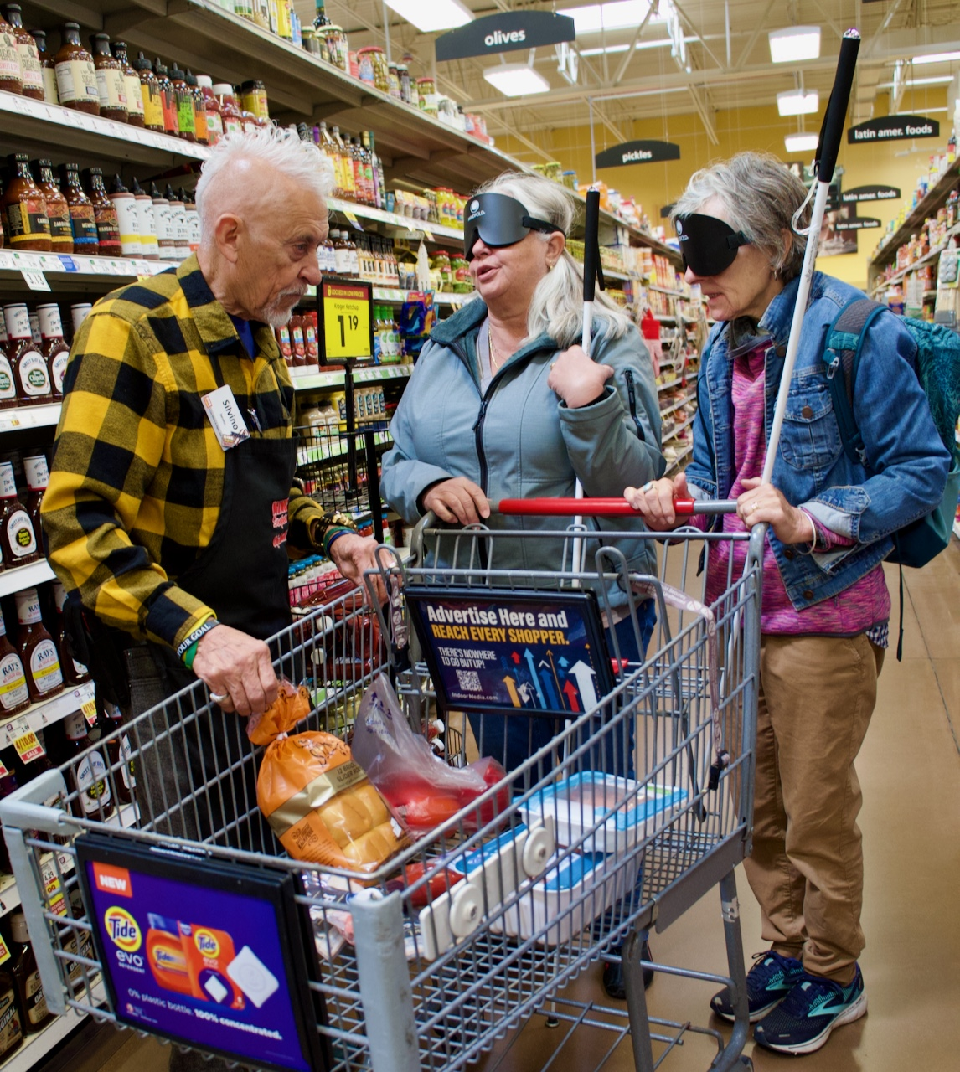
Two In Charge students with a shopping cart, laughing with a shopper’s assistant. One of the lessons of the In Charge week was that they could ask their home supermarket to provide this accommodation.
We believe that older blind people can continue to live meaningful, independent lives. We encourage and challenge them as they build the skills and confidence to continue living the independent lives they still want.

Thanking Our Partners
We want to thank all of our partners, for without them we could not provide the services that change lives.

Supporting Partners
Adams County Community Fund
Anschutz Foundation
Colorado Gives Foundation
Colorado Outdoor Equity Grant Program
Denver Children’s Foundation
Denver Foundation
DRCOG Area Agency on Aging
Ent Credit Union
InnovAge
Jay & Rose Philips Family Foundation of Colorado
Older Individuals Who are Blind Program, Division of Vocational Rehabilitation
Trimble Trust
Vicksman Trust
Virginia W. Hill Foundation
William Kistler Coors
William B. O’Rourke Foundation

Community Partners
All-Health Network
Anchor Center for Blind Children
Arapahoe Community College
Arapahoe County Master Gardeners
Arapahoe County Sherriff Mounted Unit
Auraria Telephone Pioneers
Boy Scouts Troop
South Metro Fire and Rescue
Music with Feeling
YMCA of the Rockies, Estes Park
Denver Public Schools
Colorado Cross Disability Coalition
Colorado School for the Deaf and the Blind
Colorado District 49
Colorado Talking Book Library
Denver Rock Climbing School
Dirt Coffee
Ignite Adaptive Sports
Integrated Family Community Services (IFCS)
Historic Downtown Littleton Merchants (HDLM)
Metropolitan State University of Denver
National Federation of the Blind
National Federation of the Blind of Colorado
National Science Foundation (NSF)
University of Colorado-Boulder Fiske Planetarium,
University of Colorado- Boulder Build a Better Book Project
Littleton High School
Colorado Instructional Materials Center
South Platte Park and Carson Nature Center
Denver Botanical Gardens
Eyecycle Colorado
When Everyone Acts Violence Ends (WEAVE)
Macintosh Academy

Older Blind Outreach Partners
Adams County Aging Network
Anthem Ranch Community
Arapahoe County Council on Aging
Blind Tech Training
Castle Rock Senior Activity Center
Clermont Park Senior Living Community
Community Connections, Thornton
Concordia on the Lake Retirement Community
Cycling without Age
Hudson Gardens
iCanConnect
Kavod Senior Life
River Pointe Retirement Community
Riverwalk Senior Apartments
Windcrest Senior Living

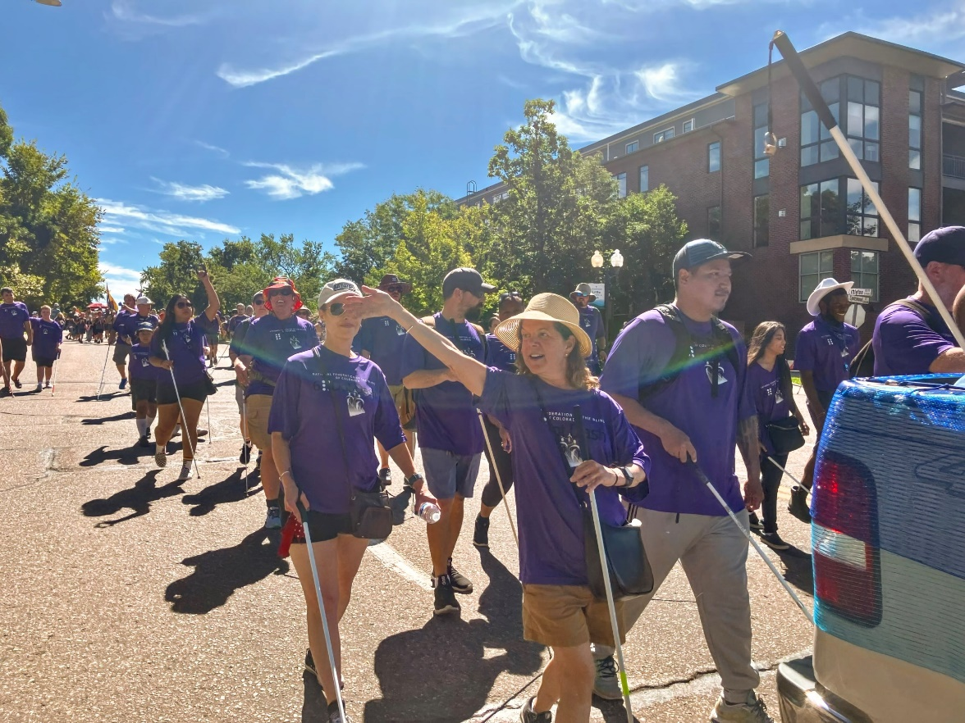
Heather waves as Jonathan walks beside her in the Western Welcome Week Parade 2024.

College, Careers and Connections: A Career Fair
This day-long event was held on September 26, with nearly 150 in attendance—including high school students from the Colorado School for the Deaf and the Blind in Colorado Springs, as well as from districts in the Denver Metro area. Keynote speakers were Littleton City Council Member Gretchen Rydin and CCB Alumnus Trevor Settles, who works as a software engineer. There was also a panel discussion featuring three blind professionals as well as breakout sessions discussing Social Security and work, disability access in college, working remotely as a blind person, the Business Enterprise Program, and more. Participants also visited sponsors and employers in our exhibit area. This is an annual event.

Sponsors:
Amazon
Target
Colorado Talking Book Library (CTBL)
City of Littleton
Dirt Coffee
Internal Revenue Service (IRS)
The National Blindness Certification Board
Arapahoe-Douglas Works

Alumni Committee Activities
Beginning in late 2022, three of our alumni spearheaded an effort to create an alumni group that would sustain the sense of community developed by students during their time in training at the Colorado Center for the Blind. In 2024, The Alumni Committee, which includes our Employment Specialist and Alumni Coordinator, continued and expanded this effort. They held monthly virtual meetups and quarterly in-person meetings in the Denver Metro area. The virtual meetups featured presentations from various alumni about their lives and careers following training at the Colorado Center for the Blind, while the quarterly events are primarily social gatherings in the Denver metro area. Online, the CCB Alumni Face Book Group continues to grow and several former students are very active there. In all, our alumni ensure their community of friendship and support keeps growing!
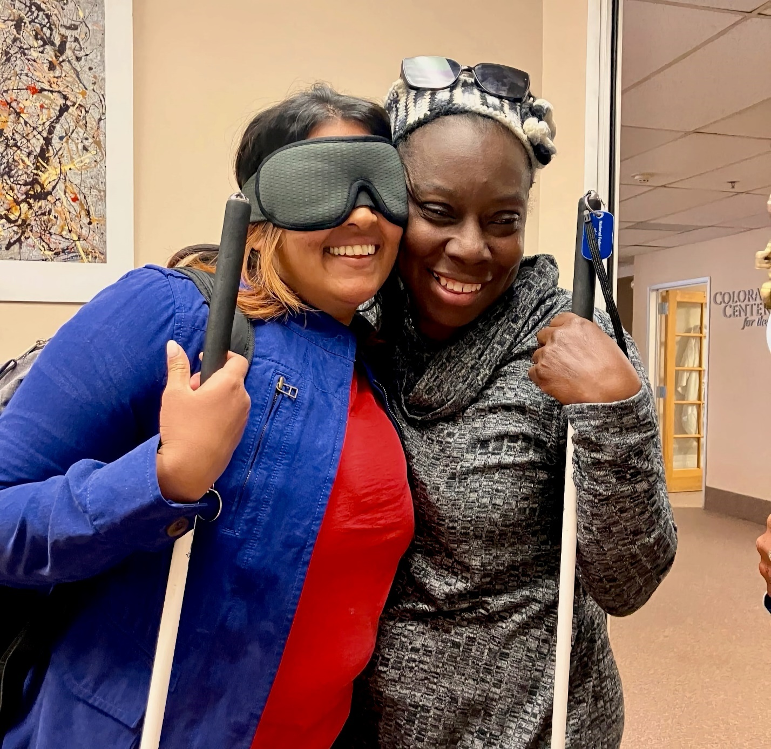
Roommates Bhavini and Nikki hug. Many lifelong friendships form at the Colorado Center for the Blind.

